**Properties of Graphs**

* Graph is an ordered pair of a set V of vertices and a set E of edges.

G=(V,E)

This is how we can represent number of vertices and edges in a graph

|V|- Number of vertices

|E| - Number of edges

* An edge is called self-loop or self edge if it involves only one vertex and both the end point of the edge are same. we can have self-loop in both directed and undirected graphs. A webpage can have link to the same page. Cosider refreshing a page .

* An edge is called multi edge if it occurs more than once in a graph. Example- Flight network. A city would be node and we can have an edge if there is direct flight connectivity between two cities. There can be multiple route to reach to one city.

* Number of edges

v1 O O v2

v3 O O v4

V={v1,v2,v3,v4}

|V|=4

Each node can have directed edge to other 3 other nodes.

Total node=4

Number of edges possible= n*(n-1)

-->In undirected graph we can have only one bi direction edge for a pair of nodes. So maximum edge possible is half of directed edges

if |V|=n then

0<=|E|<=n(n-1), if directed

0<=|E|<=n(n-1)/2, if undirected

* A graph is called dense if number of edges is close to maximum number edges.

* A graph is called sparse if number of edges are very less typically close to number of vertices.

But there is no definite definition of dense and sparse graph. It just depends on the context

* Storage structure to represent Dense graph=adjacency matrix

* Storage structure to represent sparse graph=adjacency list

* Path in a graph

A path in a graph is a sequence of vertices where each adjacent pair is connected by an edge.

In directed graph all edges should be aligned in one direction the direction of the path.

In simple path both vertices and edges are not repeated.

<A,B,F,H> - Simple path

Look at the image here

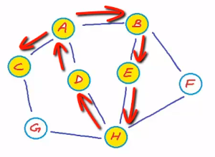

<A,B,F,H> - Simple path

<A,B,F,H,E,B,A,D> - 1 edge and two vertices are repeated.

Path - a walk in which no vertices(and thus no edges) are repeated.

Trail - a walk in which no edges are repeated.

Most often when we say path we mean simple path.

* Strongly connected graphs

If there is a path from any vertex to any other vertex

if its undirected graph we simply call connected and if its a directed graph we call it strongly connected

Look at the image here 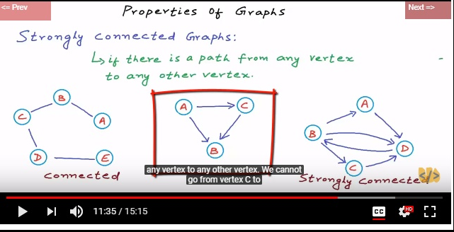

* If a directed graph is not strongly connected but can be converted to strongly connected graph by treating all edges as undirected then such a directed graph is called weakly connected.
* Closed Walk - A walk is called a closed walk if it starts and ends at the same vertex and length of the walk must be greater than 0.

Look at the image here

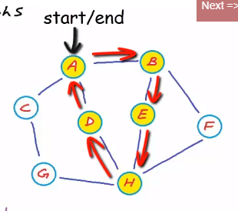

* Simple cycle – A close walk in which other than start and end vertices no other vertex are repeated.
* Acyclic graph- a graph with no cycle.

Directed acyclic graph is called DAG

Look at the image here

